**Academic Analyzer**

# A PROJECT REPORT

*Submitted by*

**Raj Bhagat (170320107007)**

**Harshal Modi (170320107055)**

**Smit Dar (170320107514)**

***In partial fulfilment for t[1]he award of degree*** ***of Bachelor of Engineering in Computer Engineering***



**COMPUTER ENGINEERING DEPARTMENT**

**L. J. INSTITUTE OF ENGINEERING AND TECHNOLOGY**

**GUJARAT TECHNOLOGICAL UNIVERSITY** **AHMEDABAD**

**YEAR, 2020-21**

**L. J. INSTITUTE OF ENGINEERING AND TECHNOLOGY**

**COMPUTER ENGINEERING DEPARTMENT**

**YEAR, 2020-21**



# **CERTIFICATE**

This is to certify that the Project entitled **”Academic Analyzer ”** submitted by **Raj Bhagat (1703207007)**, towards the partial fulfilmentof the requirements for the degree of Bachelor of Engineering in Information Technology of L.J. Institute of Engineering and Technology, Ahmedabad, under the Gujarat Technological University, Ahmedabad is the record of work carried out by him under my supervision and guidance. In my opinion, the submitted work has reached a level required for being accepted for examination. The results embodied in this project, to the best of my knowledge, haven’t been submitted to any other university or institution for award of any degree or diploma.

Mister Bhumin Mandaliya Prof. Shweta Yagnik

( Professor, L.J.) (HOD - CE)

**L. J. INSTITUTE OF ENGINEERING AND TECHNOLOGY**

**COMPUTER ENGINEERING DEPARTMENT**

**YEAR, 2020-21**



CERTIFICATE

This is to certify that the Project entitled **”Academic Analyzer”** submitted by **Harshal Modi (170320107055)**, towards the partial fulfilmentof the requirements for the degree of Bachelor of Engineering in Information Technology of L.J. Institute of Engineering and Technology, Ahmedabad, under the Gujarat Technological University, Ahmedabad is the record of work carried out by him under my supervision and guidance. In my opinion, the submitted work has reached a level required for being accepted for examination. The results embodied in this project, to the best of my knowledge, haven’t been submitted to any other university or institution for award of any degree or diploma.

Mister Bhumin Mandaliya Prof. Shweta Yagnik (Professor, L.J.) (HOD - CE)

## L. J. INSTITUTE OF ENGINEERING AND TECHNOLOGY

` **COMPUTER ENGINEERING DEPARTMENT**

### YEAR, 2020-21

# CERTIFICATE

This is to certify that the Project entitled **”Academic Analyzer”** submitted by **Smit Dar (170320107514)**, towards the partial fulfilmentof the requirements for the degree of Bachelor of Engineering in Information Technology of L.J. Institute of Engineering and Technology, Ahmedabad, under the Gujarat Technological University, Ahmedabad is the record of work carried out by him under my supervision and guidance. In my opinion, the submitted work has reached a level required for being accepted for examination. The results embodied in this project, to the best of my knowledge, haven’t been submitted to any other university or institution for award of any degree or diploma.

Mister Bhumin Mandaliya Prof. Shweta Yagnik ( Professor, L.J.) (HOD - CE)

## GUJARAT TECHNOLOGICAL UNIVERSITY

**Undertaking about originality of work**

We hereby certify that we are the sole authors of this IDP/UDP project report and that neither any part of this IDP/UDP project report nor the whole of the IDP/UDP Project report has been submitted for a degree by other student(s) to any other University or Institution.

We certify that, to the best of our knowledge, the current IDP/UDP Project report does not infringe upon anyone’s copyright nor violate any proprietary rights and that any ideas, techniques, quotations or any other material from the work of other people included in our IDP/UDP Project report, published or otherwise, are fully acknowledged in accordance with the standard referencing practices. Furthermore, to the extent that we have included copyrighted material that surpasses the boundary of fair dealing within the meaning of the Indian Copyright (Amendment) Act 2012, we certify that we have obtained a written permission from the copyright owner(s) to include such material(s) in the current IDP/UDP Project report and have included copies of such copyright clearances to our appendix.

We have checked the write up of the present IDP/UDP Project report using anti-plagiarism database and it is in the allowable limit. In case of any complaints pertaining to plagiarism, we certify that we shall be solely responsible for the same and we understand that as per norms, University can even revoke BE degree conferred upon the student(s) submitting this IDP/UDP

Project report, in case it is found to be plagiarized.

Team:

|  |  |  |
| --- | --- | --- |
| **Name of Students** | **Enrollment number** | **Signature** |
| Raj Bhagat | 170320107007 |  |
| Harshal Modi | 170320107055 |  |
| Smit Dar | 170320107514 |  |

|  |  |
| --- | --- |
| Place: Ahmedabad | Date: __________ |
| Guide: Mister Bhumin Mandaliya | (Signature of Guide) |

## ACKNOWLEDGEMENT

This project work has been the most practical and exciting part of our

learning experience, which would be an asset for us and also for our future carrier.

With a deep sense of gratitude and respect, we would like to extend our sincere thanks to the all members of this project for their kind attention and guidance which have made the dissertation successful.

No system is created entirely by individual. Many people have helped to create this system and each of their contribution has been valuable. Proper organization of concept and analysis of system is due to keen interest and helping hand of our teachers and colleagues.

We are deeply thankful to **Mrs. SHWETA YAGNIK**, Head of Department, who was a constant source of inspiration not only during this project.

Our most sincere thanks to our project guide **Mister Bhumin Mandaliya**,for his kind co-operation and who has always been guiding, encouraging and motivating us throughout the project.

Raj Bhagat (170320107007)

Harshal Modi (170320107055)

Smit Dar (170320107514)

## ABSTRACT

Academic Analyzer is an online portal for students, so that they can find and apply for suitable colleges/universities. There are few requirements that are required from the user which include desired branch and merit rank. The portal will have some specific criteria with pre-defined weightages which can be used by the student as filter in order to filter-out the desired specifications in colleges /universities. When a student applies more than one criterion then weightages will be taken into consideration and cumulative result is displayed on the screen.

In this online portal students have to submit their particular information according to their merit rank and requirements. After student fill their proper information and select proper parameters as per their choice then portal shows them best colleges/universities according to their requirements. In this poral if students enter their proper information and merit rank then portal shows accurate results according merit rank and parameters. some students and parents do not know about each colleges/universities functionalities but due to this portal students and parents can know about each colleges/universities functionalities without visiting in-person.

This portal helps the young mind to take appropriate decision regarding their further education.The chances that they might select a wrong college/university are very high.But with the help of this portal students will obtain each and every detail about a college/university which is required by the students to reach a final decision about their career**.**

INDEX

|  |  |  |
| --- | --- | --- |
| Sr. No | Topic | Page no. |
| **I** | **Acknowledgement** | VII |
| **II** | **Abstract** | VIII |
| **III** | **Table of Content** | IX |
| **IV** | **List of Figures** | X |
| **V** | **List of Tables** | XI |
| **1** | **Introduction** | 1 |
|  | 1.1 Introduction to the system  1.2 Limitation of existing system(if any)  1.3 Objective of the new system  1.4 Problem definition | 2  4  4  5 |
| **2** | **Requirement Analysis** | **6** |
|  | 2.1 Feasibility study  2.2 Requirements of the system  2.3 Tools and Technology used  2.4 Project Estimation | 7  11  11  12 |
| **3** | **System Design** | **13** |
|  | 3.1 Usecase Diagram  3.2 Activity Diagram  3.3 Sequence Diagram  3.4 State Diagram  3.5 Class Diagram  3.6 Data Flow Diagram | 14  15  18  21  12  23 |
| **4** | **Data Dictionary** | **26** |
| **5** | **Snapshot** | **29** |
| **6** | **Testing (with test cases)** | **33** |
| **7** | **Future Enhancement** | **35** |
| **8** | **Conclusion** | **36** |
| **9** | **References** | **38** |
| **10** | **Appendix** | **40** |
|  | 10.1 Periodic Progress Report (PPR)  10.2 PSAR  10.3 Canvases  10.4 Plagiarism Certificate | 41  44  50  72 |

**List Of Figures**

|  |  |  |
| --- | --- | --- |
| Sr. No | Figures | Pageno. |
| 1.1(a) | System View | 3 |
| 1.1(b) | User View | 3 |
| 1.2 | System Flow Diagram | 5 |
| 3.1 | Use case Diagram | 14 |
| 3.2(a) | Activity Diagram for User | 16 |
| 3.2(b) | Activity Diagram for Admin | 17 |
| 3.3(a) | Sequence Diagram for User | 19 |
| 3.3(b) | Sequence Diagram for Admin | **20** |
| 3.4 | State Diagram | **21** |
| 3.5 | Class Diagram | **22** |
| 3.6(a) | Level-0 DFD for Users | **23** |
| 3.6(b) | Level-1 DFD for Admin | **24** |
| 5.1 | Home Page | **30** |
| 5.2 | Registration Page | **31** |
| 5.3 | User Login | **32** |

**List Of Tables**

|  |  |  |
| --- | --- | --- |
| Sr. No | Tables | Page no. |
| 4.1 | Student Data Table | 27 |
| 4.2 | College/University Data Table | 27 |
| 4.3 | Ranking Based On Category XYZ | 27 |
| 4.4 | Recommendation Table | 28 |
| 4.5 | Admin Table | 28 |
| 4.6 | Admin Operations Table | 28 |

**Chapter: 1**

**Introduction**

1.1 **Introduction to the system:**

In this academic analyzer system students have to fill their appropriate information along with Merit rank. students have to choose some specific parameters of the colleges and universities after that website will show them best colleges and universities according to students requirements and merit rank. For instance if one student have to choose college with big campus, library and good teaching staff so student have to fill their particular parameter in portal then portal will show them best college according to student requirement and merit rank information

Some times some students have good merit rank and good academic performances but due to lack of resources and proper guidance students take admission in some other college/university rather then the particular university/college which they deserve. some students and parents are live far from the city area so some times they can not visit colleges/universities in-person so they miss the golden opportunity.so due to this online portal parents and students get to know about the each and every small details of the colleges/universities at their home by online portal.

Some times parents and students attract from the fake advertisements and take admission into the wrong university/college. Which is really very bad for their academic career and future prospective. but due this online portal students and parents get to know about each and every college/university with accurate information which is really very beneficial for their academic career and future.

**Statement about the problem:**

This very vast website so it is really very difficult task for us to manage all the data. sometimes in some colleges/universities faculties are change frequently so it is really very hard for us to update data regularly and accurately. some universities/colleges are not cooperate with us for share their important data with us. Due to this corona pandemic it is really very hard task for us to collect accurate data from each and every college/university.

**There are the two views of the system:**

1. System view
2. User view

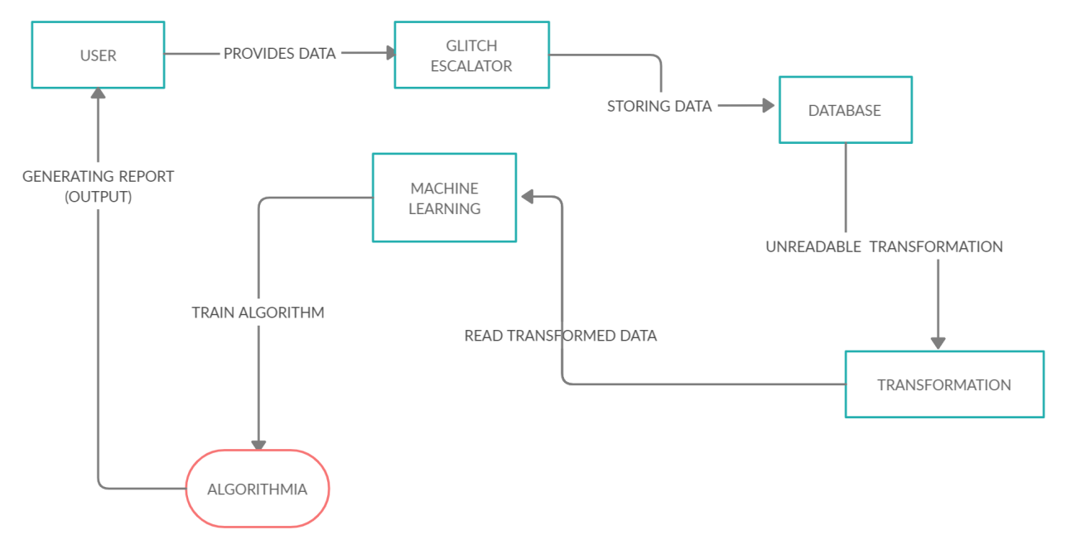

#### [Fig 1.1(a):- System view]

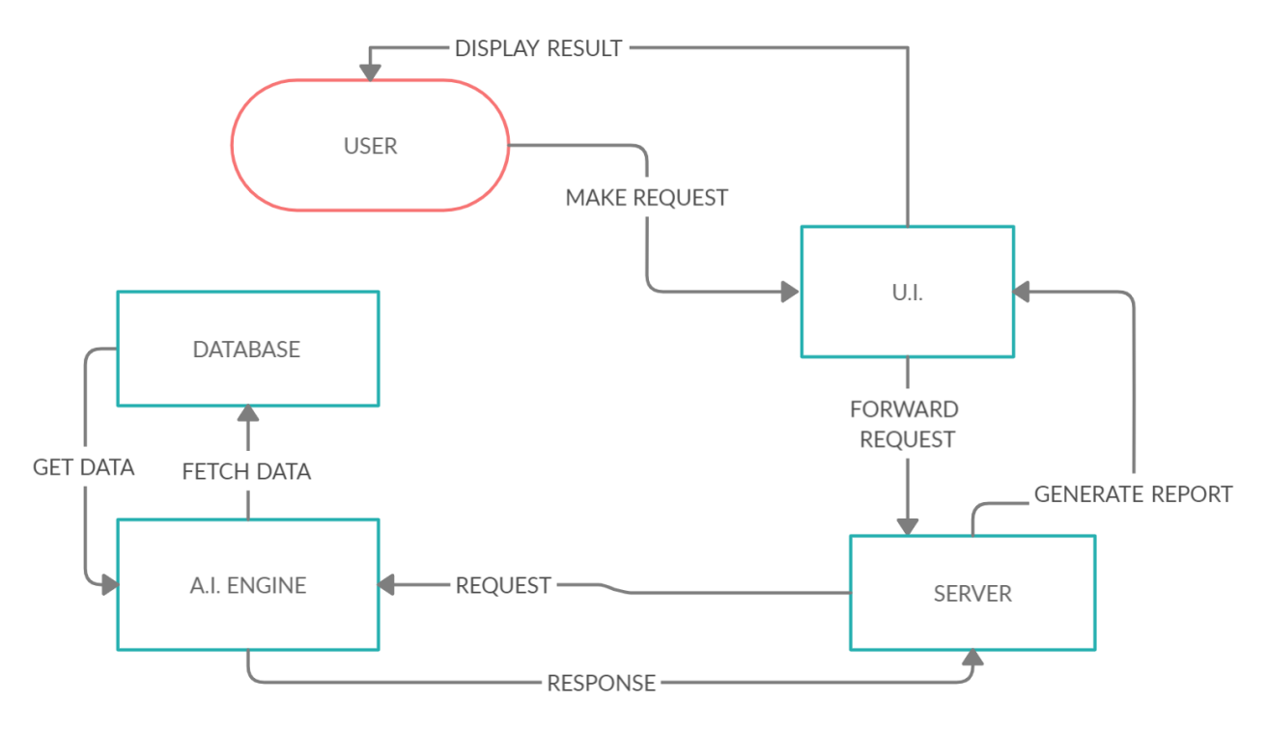

**[Fig 1.1(b):- User View]**

### 1.2 Limitation of existing system

There were many problems or limitations exist in normal flow of working. Some of them are given below as follows: -

* Developer’s code is not effectively optimized.
* They can’t find every possible defects or bugs in a system.
* Finding accurate data about colleges/universities is very difficult
* They can’t make every possible testcases.

### 1.3 Objective of the new system

There are many objectives of the new system that overcomes the limitations of the existing work flow. The objectives are as follows: -

* **To improve the efficiency of the new system:**
  + By gathering adequate amount of data to figure out the probable trend in the educational field.
  + Try to get the most accurate data possible.
  + Make the portal accessible for more number of users.
* **To be more helpful and supportive for students**
* By providing contact details of alumini of different colleges/universities.
* By providing students with mentors for helping and guiding them.

**1.4 Problem definition**

Sometime it is really very hard to collect all the information due to this corona pandemic. Sometimes due to lack of internet connectivity and lack of knowledge parents and students can not take the advantages from online portal . some universities/colleges are never cooperate with us for sharing their important data so we have to only relay on their online website which is biggest disadvantages for students.

Sometimes many colleges and universities change their faculty frequently so on that time it is biggest challenge for us to maintain accurate data online.it is really very hard and difficult task for us to update such vast data online regularly. Some colleges and universities can not give us accurate data witch is also major drawback for us and students.

**Keeping in mind the following three steps:**

1. The system has to have some models generating Academic analyser using java ,python and Machine Learning Techniques

2. This website always try to show accurate data and best colleges according to student merit rank and requirements. The website show wrong data only if colleges or universities give us fake data.

3. Website always gives proper and appropriate suggestions according to student parameter choice, merit rank and requirements.

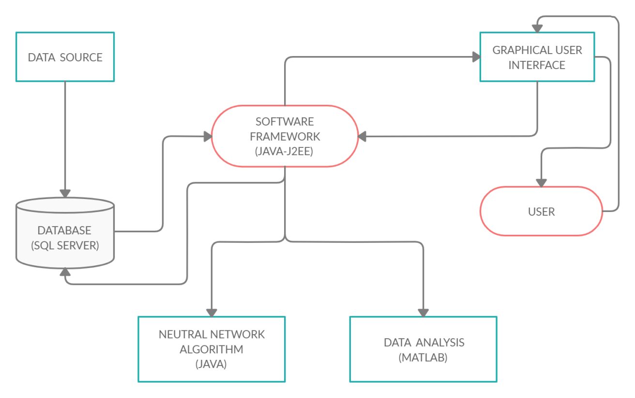

**1.2 [SYSTEM FLOW DIAGRAM]**

# Chapter: 2

**Requirement Analysis**

**2.1 Feasibility study**

A feasibility study is used to determine the viability of an idea, such as ensuring a project is legally and technically feasible as well as economically justifiable.

## ⮚ Technical Feasibility:

A large part of determining resources has to do with assessing technical feasibility. It considers the technical requirements of the proposed project. The technical requirements are then compared to the technical capability of the organization. The systems project is considered technically feasible if the internal technical capability is sufficient to support the project requirements.

The analyst must find out whether current technical resources can be upgraded or added to in a manner that fulfils the request under consideration. This is where the expertise of system analysts is beneficial, since using their own experience and their contact with vendors they will be able to answer the question of technical feasibility. The essential questions that help in testing the technical feasibility of a system include the following:

1.Is the project feasible within the limits of current technology?

2.Does the technology exist at all?

3.Is it available within given resource constraints?

4.Is it a practical proposition?

5.Manpower- programmers, testers & debuggers

6.Software and hardware

7.Are the current technical resources sufficient for the new system?

8.Can they be upgraded to provide to provide the level of technology necessary for the new system?

9.Do we possess the necessary technical expertise, and is the schedule reasonable?

10.Can the technology be easily applied to current problems?

11.Does the technology have the capacity to handle the solution?

12.Do we currently possess the necessary technology?

Automated Stock Prediction system deals with the modern technology system that needs the well efficient technical system to run this project. All the resource constrains must be in the favour of the better influence of the system. Keeping all these facts in mind we had selected the favourable hardware and software utilities to make it more feasible.

## ⮚ Economic feasibility:

Economic analysis could also be referred to as cost/benefit analysis. It is the most frequently used method for evaluating the effectiveness of a new system. In economic analysis the procedure is to determine the benefits and savings that are expected from a candidate system and compare them with costs. If benefits outweigh costs, then the decision is made to design and implement the system. An entrepreneur must accurately weigh the cost versus benefits before taking an action.

Possible questions raised in economic analysis are:

1.Is the system cost effective?

2.Do benefits outweigh costs?

3.The cost of doing full system study

4.The cost of business employee time

5.Estimated cost of software/software development

6.Is the project possible, given the resource constraints?

7.What are the savings that will result from the system?

8.Cost of employees' time for study

9.Cost of packaged software/software development

10.Selection among alternative financing arrangements (rent/lease/purchase)

The concerned business must be able to see the value of the investment it is pondering before committing to an entire system study. If short-term costs are not overshadowed by long-term gains or produce no immediate reduction in operating costs, then the system is not economically feasible, and the project should not proceed any further. If the expected benefits equal or exceed costs, the system can be judged to be economically feasible. Economic analysis is used for evaluating the effectiveness of the Proposed System. The economic feasibility will review the expected costs to see if they are in-line with the projected budget or if the project has an acceptable return on investment. At this point, the projected costs will only be a rough estimate. The exact costs are not required to determine economic feasibility. It is only required to determine if it is feasible that the project costs will fall within the target budget or return on investment. A rough estimate of the project schedule is required to determine if it would be feasible to complete the systems project within a required timeframe. The required timeframe would need to be set by the organization.

## ⮚ Operational Feasibility:

Operational feasibility is a measure of how well a proposed system solves the problems, and takes advantage of the opportunities identified during scope definition and how it satisfies the requirements identified in the requirements analysis phase of system development. Operational feasibility reviews the willingness of the organization to support the proposed system. This is probably the most difficult of the feasibilities to gauge. In order to determine this feasibility, it is important to understand the management commitment to the proposed project. If the request was initiated by management, it is likely that there is management support and the system will be accepted and used. However, it is also important that the employee base will be accepting of the change. The operational feasibility is the one that will be used effectively after it has been developed. If users have difficulty with a new system, it will not produce the expected benefits. It measures the viability of a system in terms of the PIECES framework. The PIECES framework can help in identifying operational problems to be solved, and their urgency:

**1.Performance**: Does current mode of operation provide adequate throughput and response time?

As compared to traditional methods of manually retrieving the stock data from the web and forecasting the stock prices with large number of manual calculations, this system plays a very important role in designing an application that automates the process of data retrieval and stock movement/price prediction with the help of a user-friendly dashboard, thus making the processeasier and faster.

**2.Information**: Does current mode provide end users and managers with timely, pertinent, accurate and usefully formatted information?

System provides end users with timely, pertinent, accurate and usefully formatted information. Since all the stock related information is being pulled from Yahoo Finance against a unique NSE Stock Symbol, it will provide for meaningful and accurate data to the investor. The investing decisions are made by the traditional investors manually. This results in loss of validity of data due to human error. The information handling and the investing decision in the proposed system will be driven by computerized and automatically updated prediction and validation of stock data. The human errors will be minimal. The data will be automatically updated from time to time and will be validated before the data is processed into the system.

**3.Economy**: Does current mode of operation provide cost-effective information services to the business? Could there be a reduction in costs and/or an increase in benefits?

Page 13 of 76

Determines whether the system offers adequate service level and capacity to reduce the cost of the business or increase the profit of the business. The deployment of the proposed system, manual work will be reduced and will be replaced by an IT savvy approach. Moreover, it has also been shown in the economic feasibility report that the recommended solution is definitely going to benefit economically in the long run. The system is built on Excel, R and JavaScript. Excel and Javascript do not need any additional installation; they are in-built in every system. R needs installation but it is free software. So, overall the application is very economically feasible.

**4.Control**: Does current mode of operation offer effective controls to protect against fraud and to guarantee accuracy and security of data and information?

As all the data is pulled from Yahoo Finance, which is a public stock data provider, it does not contain any confidential information which can be misused, so on that contrast there should be no use of any security corner for this system.

**5.Efficiency**: Does current mode of operation makes maximum use of available resources, including people, time, and flow of forms?

Efficiency work is to ensure a proper workflow structure to store patient data; we can ensure the proper utilization of all the resources. It determines whether the system makes maximum use of available resources including time, people, flow of forms, minimum processing delay. In the current system a lot of time is wasted as the investing decisions are made by the traditional investors manually. The proposed system will be a lot efficient as it will be driven by computerized and automatically updated prediction and validation of stock data. The data will be automatically updated from time to time and will be validated before the data is processed into the system.

**6.Services**: Does current mode of operation provide reliable service? Is it flexible and expandable?

The system is desirable and reliable services to those who need it and also whether the system is flexible and expandable or not. The proposed system is very much flexible for better efficiency and storage capacity of the system can be increased as per requirement. This will provide a strong base for expansion. The new system will provide a high level of flexibility.

## ⮚Schedule Feasibility:

We may have the technology, but we may not have the skills required to properly apply that technology. All information systems professionals can learn new technologies, but that learning curve will impact the schedule of the project.

System Planning (PERT & Gantt Chart):

PERT (program evaluation and review technique) and CPM (critical path method), are available to assist the management of a large-scale project that requires coordinating numerous activities. A myriad of details must be considered in planning how to coordinate all these activities, in developing a realistic schedule, and then in monitoring the progress of the project. These techniques make heavy use of networks to help plan and display the coordination of all the activities.

The original versions of PERT and CPM had some important differences. However, they also had a great deal in common, and the two techniques have gradually merged further over the years.

A Gantt Chart is a timeline that is used as a project management tool to illustrate how the project will run. You can view individual tasks, their durations and the sequencing of these tasks. View the overall timeline of the project and the expected completion date.

The Gantt chart and the PERT chart are probably the two best known charts in project management. Each of these can be used for scheduling, but because Gantt charts don't illustrate task dependencies and PERT charts can be confusing, PMs often use both.

## 2.2 Requirements of system (Functional & Non-functional)

### ❖ Functional Requirements

Functional requirement are the functions or features that must be included in any system to satisfy the business needs and be acceptable to the users. Based on this, the functional requirements that the system must require are as follows:

1. The system should be able to predict the approximate share price movement.
2. The system should collect accurate data from the particular API in consistent manner.

### ❖ Non-Functional Requirements

Non-functional requirement is a description of features, characteristics and attribute of the system as well as any constraints that may limit the boundaries of the proposed system. The non- functional requirements are essentially based on the performance, information, economy, control and security efficiency and services. Based on these the non-functional requirements are as follows:

1. The system should provide better accuracy.
2. The system should have simple interface for users to use.
3. To perform efficiently in short amount of time.

## 2.3 Tools and Technology used

### ❖ Tools: -

* Laptop
* Desktop
* WIFI
* MySQL
* Sublime text 3
* Eclipse
* Anaconda

### ❖ Technology

* **Front End** 
  + HTML
  + CSS
  + JavaScript
  + Microsoft Excel 2007

* **Back End** 
  + Python
* IIS Server local host configuration
* Machine Learning
* Artificial Intelligence

# Chapter: 3

**System Design**

**3.1 Use case Diagram:**

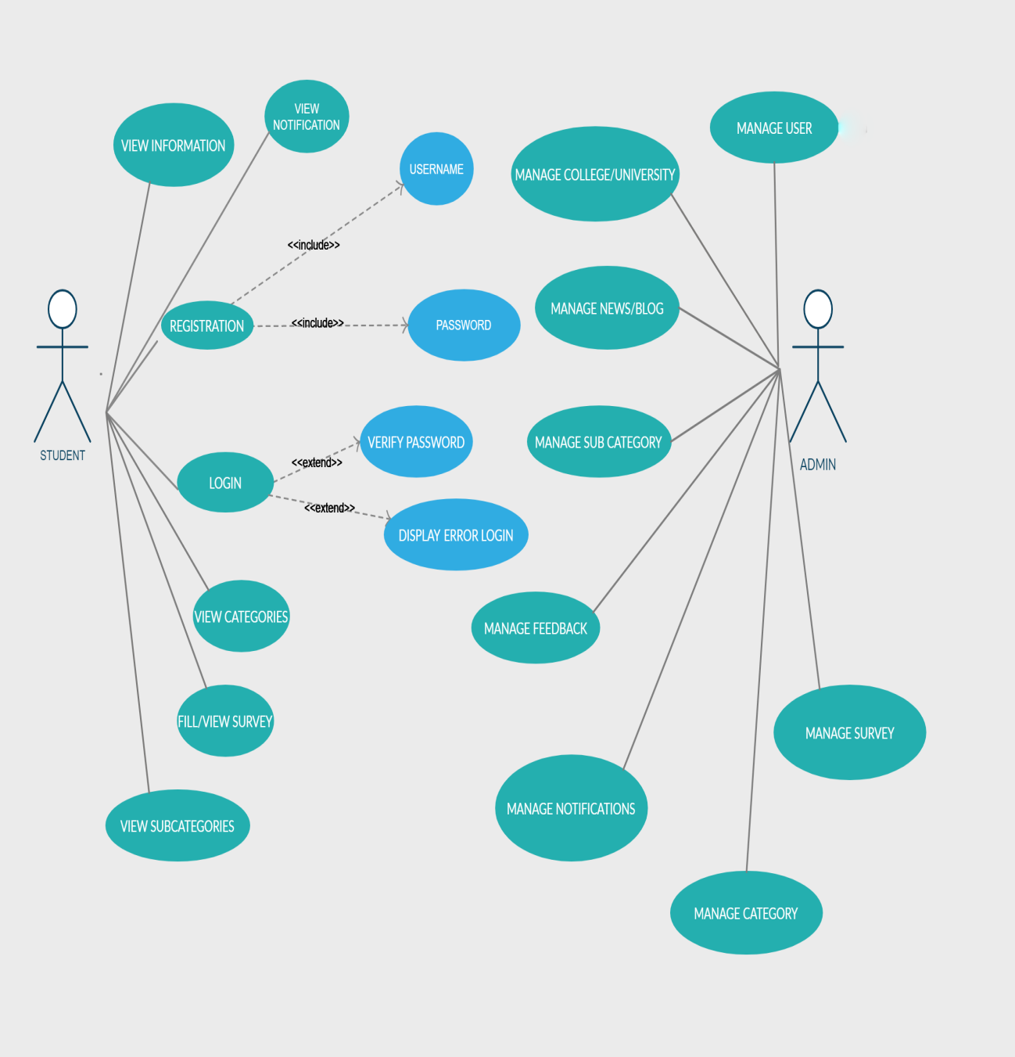

**[Figure 3.1]**

**Login**: The admin can enter the system by providing correct credentials.

**Registration**: All important details are entered like name and email into the database.

**View/Fill survey**: The user can fill the available surveys or view the result of surveys filled by others.

**View Information**: The Users can view information about various colleges/universities.

**View categories**: The user can view different criteria for selection.

**Manage User:** The admin can view the profile of the users in order to keep a check on them.

**Manage feedback**: Admin can view the feedbacks of the users at any time.

**Manage News/Blogs**: The admin can post latest news and blogs for users.

**Manage college/university**: The admin can make modifications and post the latest updates about colleges/universities.

**Manage survey**: The admin can view the result of surveys filled by others.

**Manage category**: The admin can update given categories.

**3.2 Activity Diagram:**

* **User’s Activity Diagram:**

**Registration:** the user has to register themselves with the required details.

**Login:** The user has to login using correct credentials to access the system.

**Server Request**: The server throws a request .

**Show response**: If the request are fulfilled the response is generated.

**Insert branch**: The user has to enter the desire branch.

**Insert merit**: The user inserts their merit rank .

**Process data**: The data is collected and processed.

**Result**: The outcome is generated on the basis of given inputs.

**Cumulative rankings**: The rankings are displayed .

**Give Feedback**: The user can provide their feedback whenever they want to.

**View/Fill survey**: The user can fill the available surveys or view the result of surveys filled by others.

**Logout**: The user can logout when he is done using the portal.

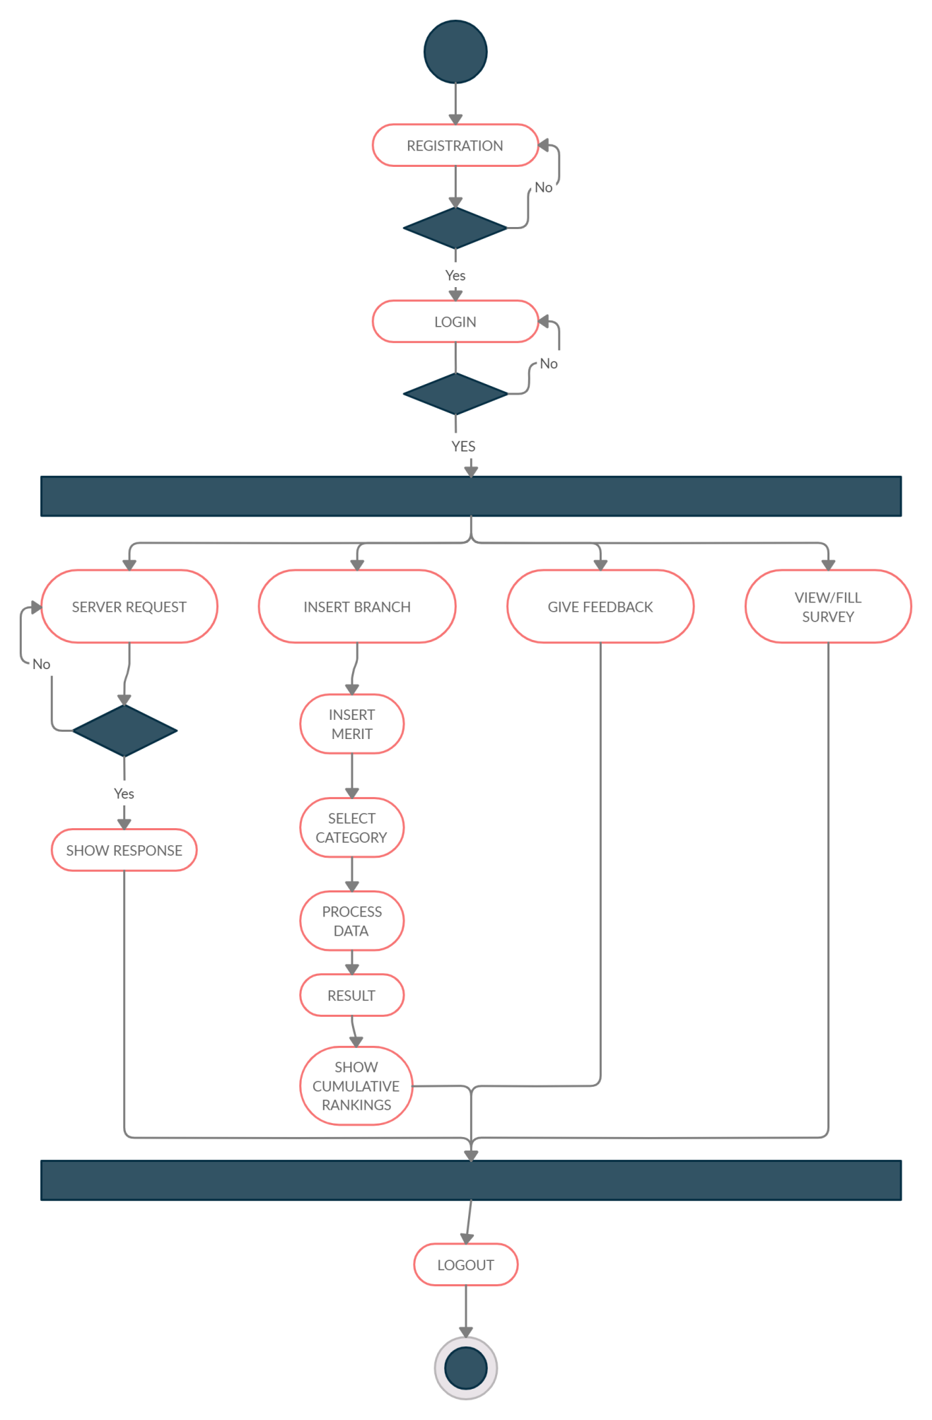

**[Fig 3.2(a):- User Activity Diagram]**

* **Admin Activity Diagram:**

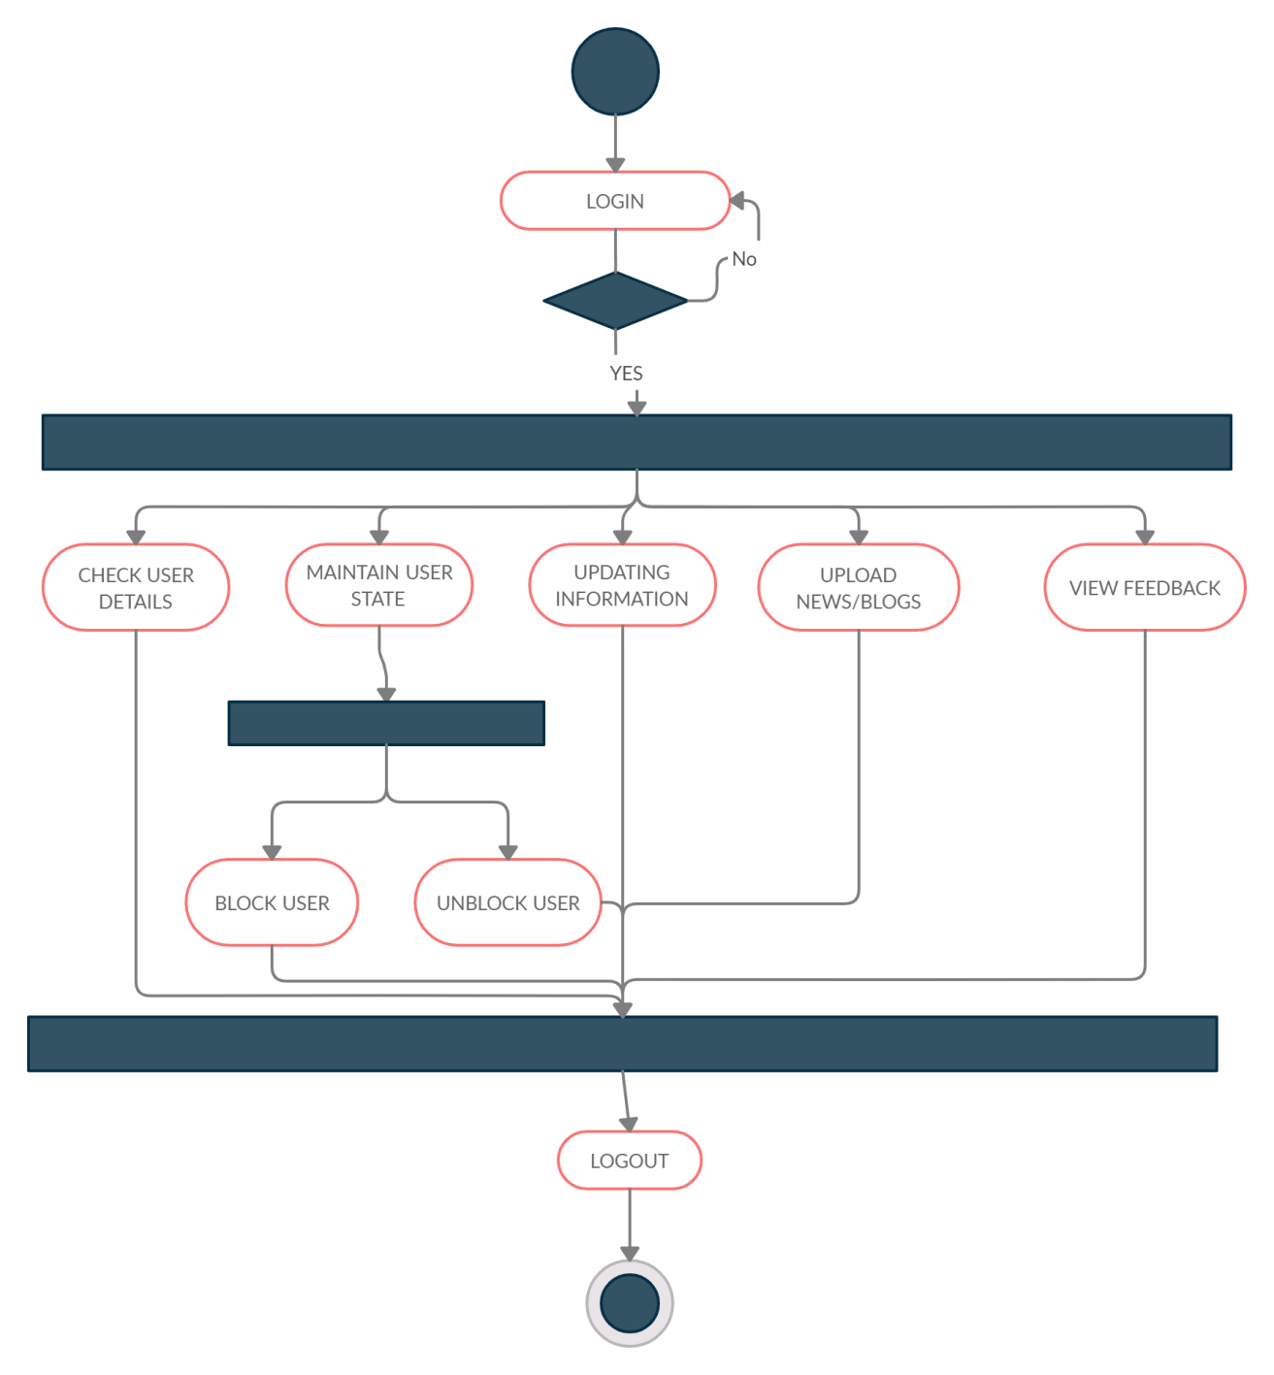

**[Fig 3.2(b) :- Admin’s Activity diagram]**

**Login**: The admin can enter the system by providing correct credentials.

**Check User**: The admin can view the profile of the users in order to keep a check on them.

**Maintain User State**: There are two main states, block and unblock. The admin can block or unblock a user at any given time.

**Block User**: Once the admin blocks a user he is no longer able to access the system.

**Unblock user**: If a user is blocked then he can be unblocked by the admin and the user can access the system again.

**Updating Information**: The admin can make modifications and post the latest updates.

**Upload News/Blogs**: The admin can post latest news and blogs for users.

**View feedback**: Admin can view the feedbacks of the users at any time.

**Logout**: Once the admin has done his work he can leave.

**3.3 Sequence Diagram**

* **User Sequence Diagram:**

The users first register themselves and the provide the required details. Then the users can login themselves going through the process of authentication. After that the user inserts the desired branch and that is stored in the database. Furthermore, they will be asked to insert their merit rank which would be stored in the database. Then the users can choose from various category filters that which category they wish to choose. All this data is fetched and results are generated accordingly and displayed to the user on their screen.

**[Fig 3.3(a):- User Sequence Diagram]**

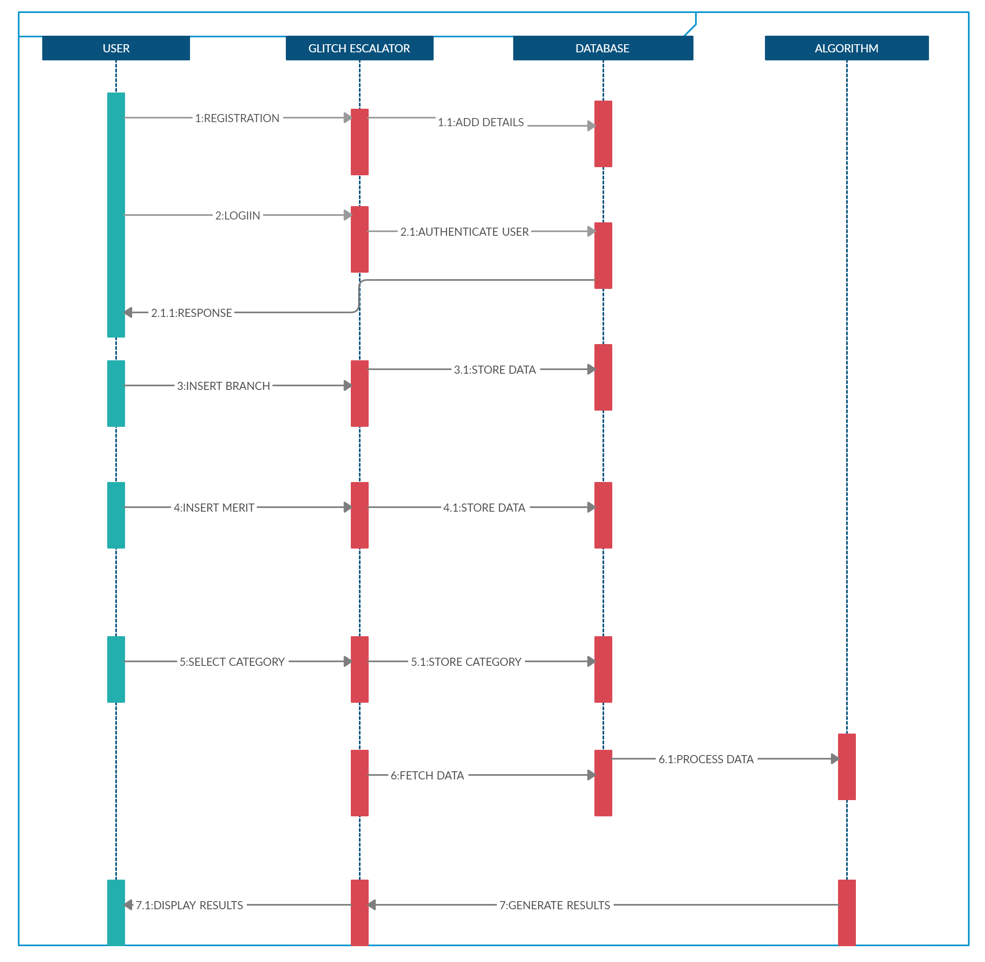

* **Admin Sequence Diagram:**

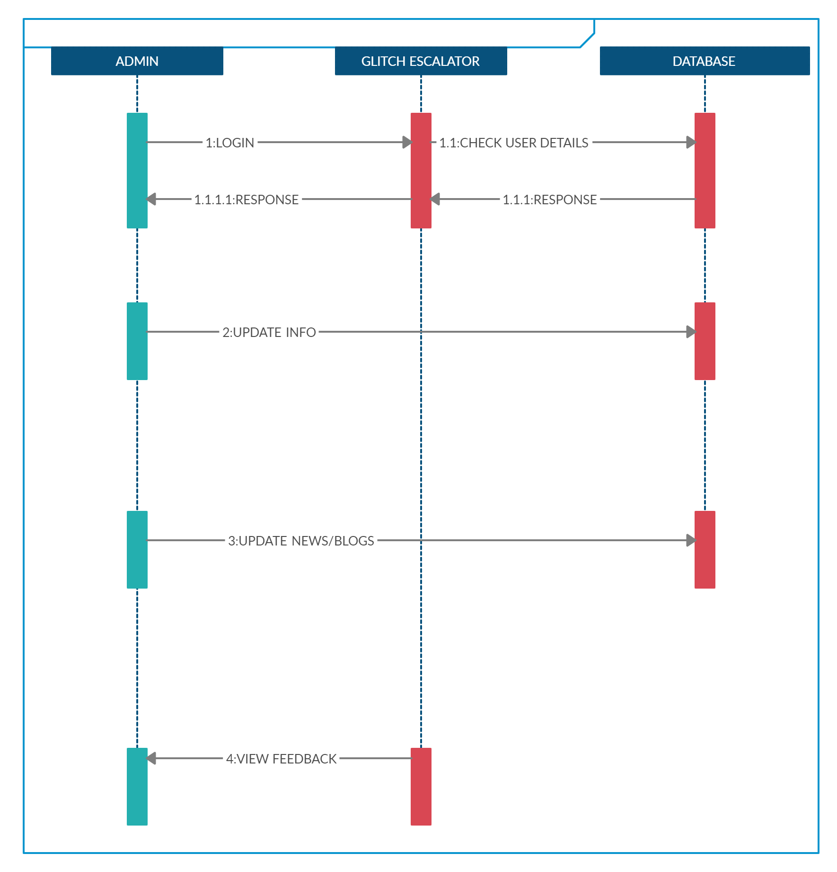

**[Fig 3.3(b) :- Admin’s Sequence diagram]**

Admin first provides login credentials to login into the system glitch escalator. The system will check the credentials in the database and send authentication acknowledgement to the admin. The admin can check user’s details, feedbacks and inquiries from the users and give them responses.

**3.4 State Diagram**

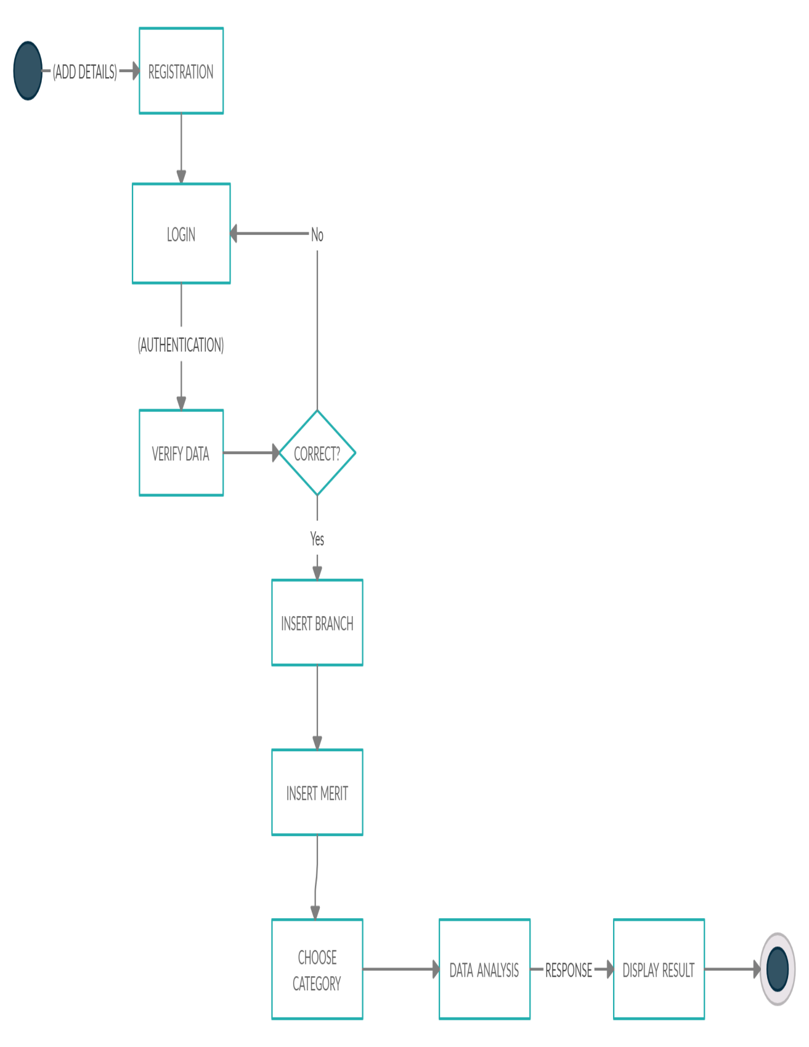

**[Fig 3.4 : State diagram]**

The details of the user are collected through registration and then given further for authentication. Once the data is verified the user can enter the branch, merit rank, and choose the category they wish to choose and then as they submit all these details then the data is analysed and then results are displayed.

**3.5 Class Diagram**

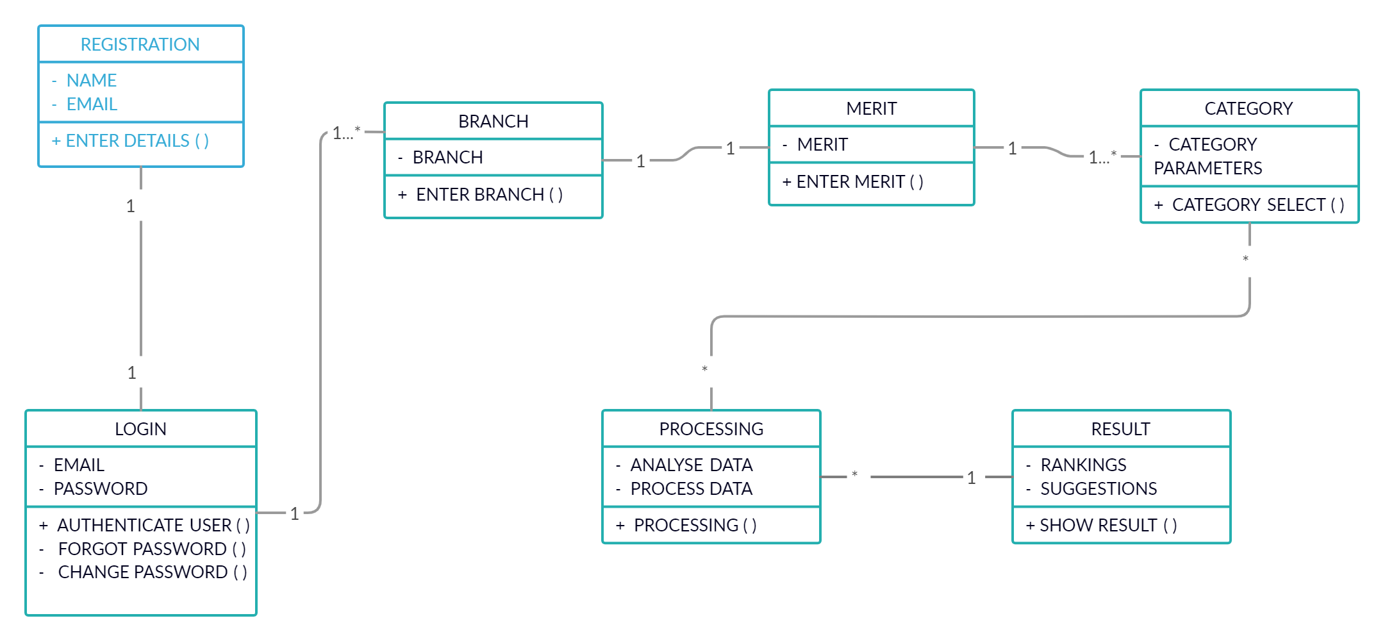

**[Fig 3.5 :- Class diagram]**

**Registration**: All important details are entered like name and email into the database.

**Login**: The name and password is to be entered and the user will be allowed to access the portal after their authentication.

**Branch**: The desired branch is entered by the user and stored in the database.

**Merit**: The Merit rank of the student is entered and stored in the database.

**Categories**: Pre-defined criteria with pre-assigned weightages are provided for the students to use them as filters in order to get desired outputs.

**Processing**: The data provided by the user is collected and analysed. Processing is done on the basis of category selected by the user.

**Result**: The rankings and the suggestions are displayed on the user’s screen.

**3.6 Data Flow Diagram**

* **Admin’s Data Flow Diagram:** 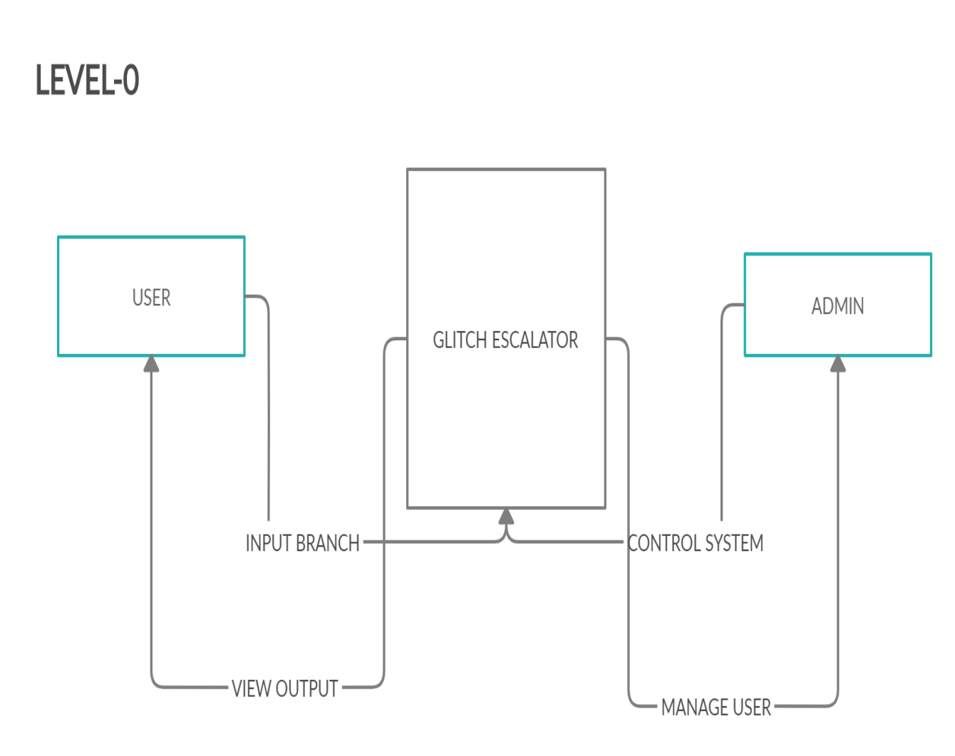

**[Fig 3.6(a):- Level-0 DFD For User]**

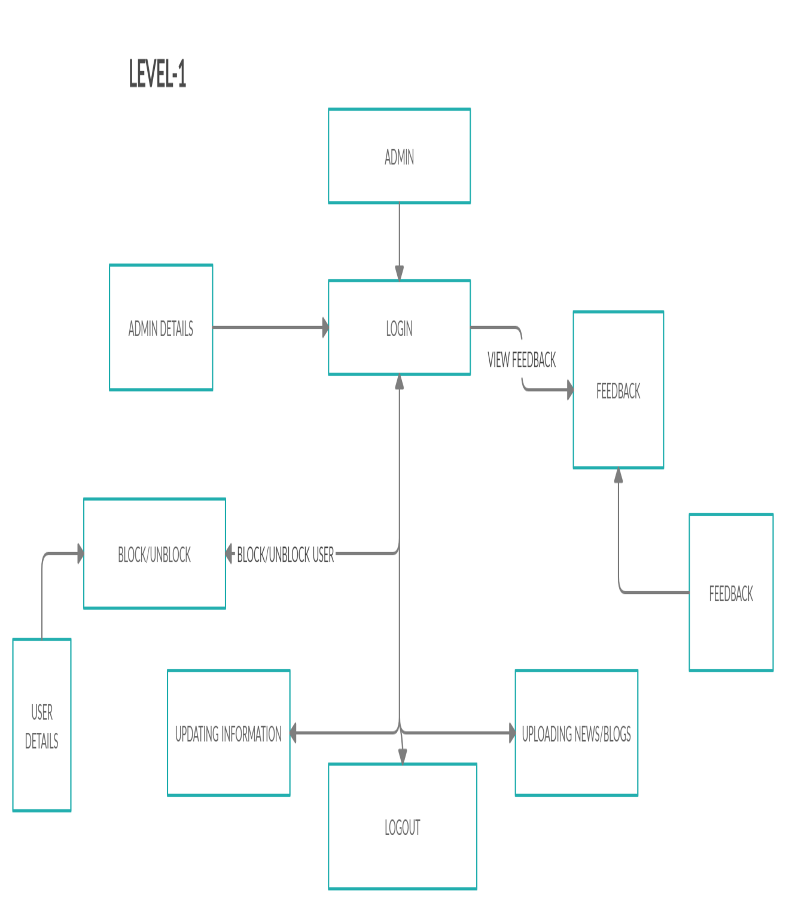

**[Fig 3.6(b):- Level-1 DFD For Admin]**

Level-1 DFD of Admin includes work flow of admin in the system where admin firstly login into the system by providing login credentials. Then he will do further operations. He can see the feedbacks of the users, can solve the queries of their if any. If the users are misusing their privileges then admin can block the users or can unblock the user as per their behaviours. He can also check the user’s details and finally he can logout from the system.

# Chapter: 4

**Data Dictionary**

**Table 4.1 :- Student Data Table**

|  |  |  |  |
| --- | --- | --- | --- |
| Field Name | Data Type | Constraint | Discription |
| Id | int | Primary Key | Unique identifier |
| Student | varchar(20) | Not Null | Student name |
| First_Name | varchar(20) | Not Null | Student’first name |
| Last_Name | varchar(100) | Not Null | Student’last name |
| Merit_rank | int | Not Null | Student merit rank |
| Gender | varchar(20) | Not Null | Gender |
| Marksheet | varchar(20) | Not Null | Marksheet |
| Age | int | Not Null | Age |

**Table 4.2 :- College/University data table**

|  |  |  |  |
| --- | --- | --- | --- |
| Field Name | Data Type | Constraint | Discription |
| Id | int | Primary Key | Unique identifier |
| Clg_Name | varchar(20) | Not Null | College Name |
| Uni_Name | varchar(20) | Not Null | University name |
| Faculty | varchar(100) | Not Null | Faculty name |
| Hod | varchar(50) | Not Null | Hod name |
| Placement | varchar(50) | Not Null | Placement |
| Branch | varchar(50) | Not Null | Specific Branch |
| Fees | int | Not Null | Fees |

**Table 4.3 :-Ranking Based On Category - XYZ**

**Table**

|  |  |  |  |
| --- | --- | --- | --- |
| Field Name | Data Type | Constraint | Description |
| Rank | int | Not null | Rank of colleges |
| Id | int | Primary key | id |
| Clg_name | varchar(50) | Not Null | College Name |
| Uni_name | varchar(30) | Not Null | University Name |

**Table 4.4 :- Recommendation Table**

|  |  |  |  |
| --- | --- | --- | --- |
| Field Name | Data Type | Constraint | Discription |
| Id | int | Primary Key | Unique identifier |
| Branch | varchar(50) | Not Null | Chosen Branch |
| Merit | int | Not Null | Merit Rank |
| Suggested institute | varchar(30) | Not Null | Institute name |
| Description | varchar(15) | Not Null | Information |

**Table 4.5 :- Admin Table**

|  |  |  |  |
| --- | --- | --- | --- |
| Field Name | Data Type | Constraint | Discription |
| Id | int | Primary Key | Unique identifier |
| U_name | varchar(50) | Not Null | User Name |
| U_surname | varchar(50) | Not Null | User Surname |
| pwd | varchar(30) | Not Null | password |
| Modifications | varchar(15) | Not Null | Modification |
| Delete | varchar(50) | Not Null | Deletion |

**Table 4.6 :- Admin Operations Table**

|  |  |  |  |
| --- | --- | --- | --- |
| Field Name | Data Type | Constraint | Description |
| Id | int | Primary Key | Unique identifier |
| Manage User State | varchar(50) | Not Null | Block/Unblock |
| Upload news/blogs | varchar(50) | Not Null | Latest News/blogs |
| View Users | varchar(30) | Not Null | Check Users |
| View Surveys | varchar(15) | Not Null | Check Surveys |
| View Feedback | varchar(50) | Not Null | Check Feedback |
| Update | varchar(50) | Not Null | Latest Updates |

**Chapter: 5**

**Snapshot**

* **Registration page of the system where user has to register with all the required data before doing the further operations in the system.**

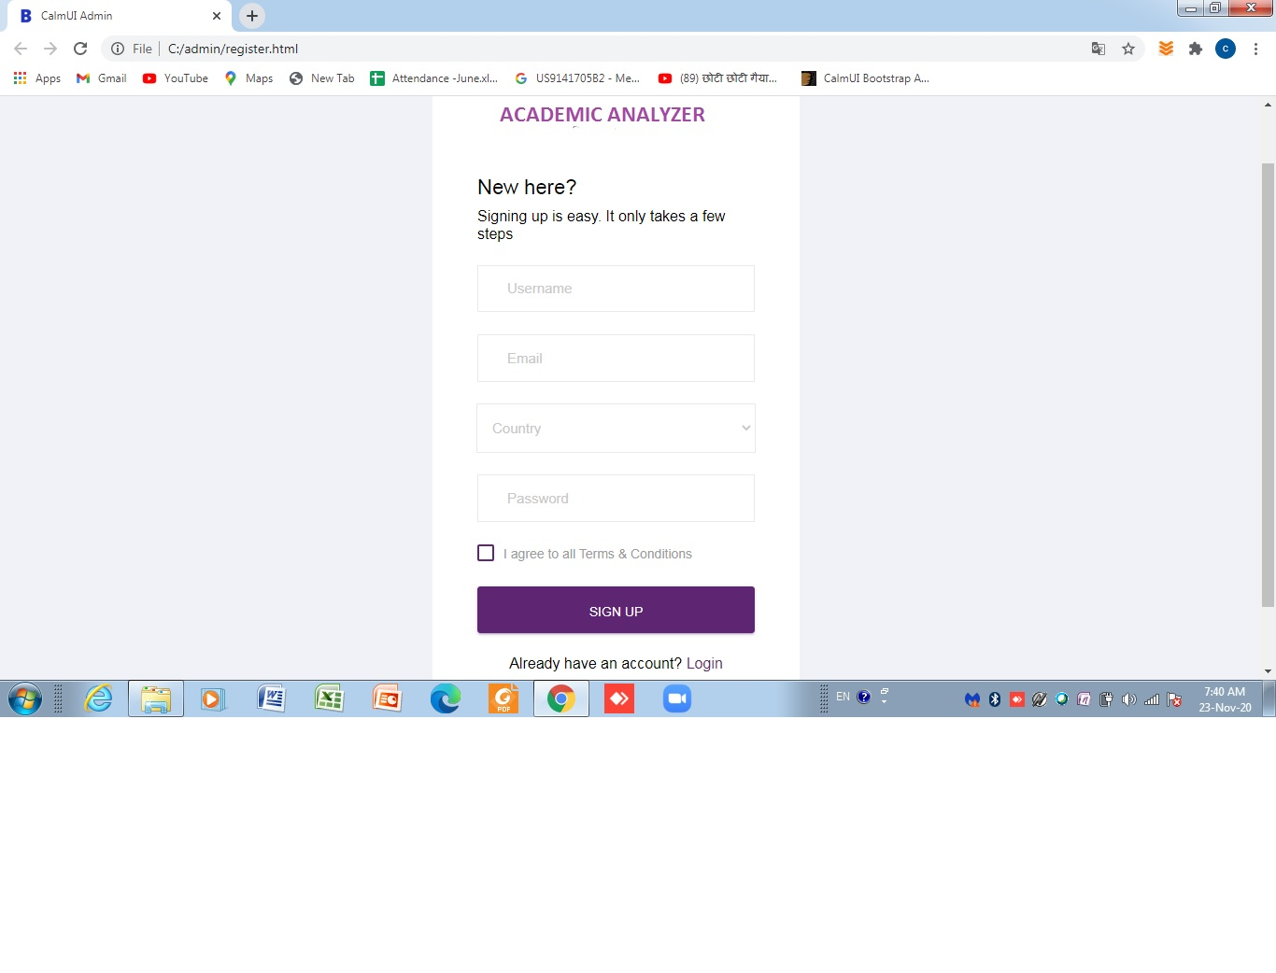

**[Fig 5.1 :- Registration]**

## 

## Login page of the system where user and admin has to provide login credentials for authentication purpose and proceed for further operations.

## login [Fig 5.2 :- Log in]

* **After log in user come to know about news regarding to investment, portfolio and about the features of an application.**

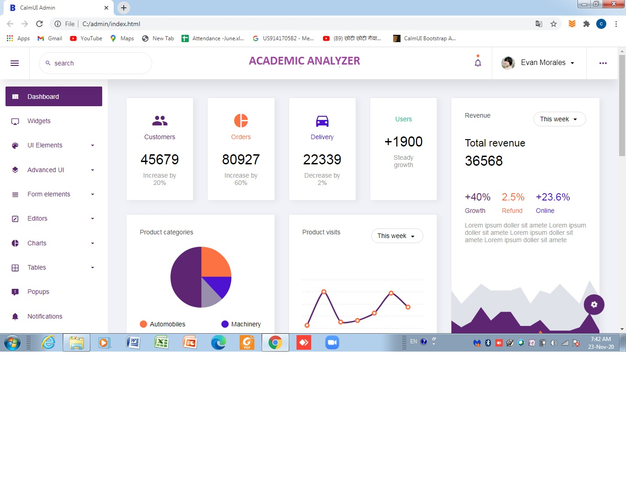

## [Fig 5.3 :- Home]

# Chapter : 6

**Testing (with test cases)**

### 

### **Testing of algorithm with necessary test cases**

## Description:-

Firstly committers will commit their code and it will be reviewed or tested by the testers or reviewers.

Then reviewer or tester will check module and predict or analyse whether the bug will be found or not. It may be possible that bug can be found either tester end or customer end.

Here we have some test cases which shows whether the machine’s prediction is correct or not based on previous prediction of reviewer or tester. It may be possible that machine’s prediction can be wrong. And at the end we got the result that shows possiblities of occurrence of bug.

|  |  |  |
| --- | --- | --- |
| **Committers**  **(as per revisions)** | **Reviewer’s Prediction** | |
| **Reviewers** | **Prediction** |
| Committer_1 | Reviewer_1 | 1 |
| Committer_1 | Reviewer_2 | 0 |
| Committer_1 | Reviewer_1 | 0 |
| Committer_1 | Reviewer_1 | 1 |
| Committer_1 | Reviewer_2 | 1 |

### [Fig. 6.5:- Training and Testing data (Reviewer’s prediction)]

|  |  |  |  |  |  |
| --- | --- | --- | --- | --- | --- |
| **State** | **Committers** | **Reviewer’s Prediction** | | **Machine’s Prediction** | **Result** |
| **Reviewers** | **Prediction** |
| Initial | Committer_1 | Reviewer_1 | 1 | 1 | 1 |
| Committer_1 | Reviewer_2 | 1 | 1 | 1 |
|  | Committer_1 | Reviewer_1 | 0 | 1 | 1 |
|  | Committer_1 | Reviewer_1 | 0 | 0/1 | 0 |
| 0 | 0/1 | 1 |

**[Fig. 6.6:- Machines’s prediction]**

**Chapter: 7**

**Future Enhancement**

## Future Enhancement

## More mutually affecting Independent variables can be added for better prediction results

## More advanced prediction algorithms such as Logistic Regression, Neural Networks, etc. can be use to enhance the quality of the Prediction

* Portfolio management can be added to our existing analysis. Portfolio management is largely an extra step done after an investor has made a prediction on which direction any particular stock will move. For instance, the investor may choose not to invest all of their funds into a single company lest that company takes unexpected turn.

**Chapter: 8**

**Findings & Conclusion**

**Conclusion:-**

To summarize, in this project we attempt to build an academic analyzer system based on Machine Learning algorithms and Python models.This website will be helpful for students to get admission in particular college/university as per their merit rank and different parameter requirements.Students can search different category on online portal and choose appropriate college/university according to their requirement.After they search particular parameter on online portal then website will show them best colleges/universities as per their merit rank.

Following are some of the important findings that were discovered after building the project.

-We observed that student choose college/university without visiting or surveying them properly and then feel dissatisfied with its lack of infrastructure.

-Some universities/colleges post various attractive offers on their website to attract students and parents but due to lack of knowledge about such institutions, students fall in their trap and make wrong decisions.

-We saw that some times some students had good academic performance and merit rank but due to lack of resources and knowledge about parameters of universities and colleges they did not get admission into particular colleges/universities as they deserved.

-Some parents send their children into government colleges/universities for financial and other benefits but don’t know about private colleges/universities features.So this website will provide them accurate information about all government and private colleges/universities and shows a comparison between them.

**Chapter: 9 References**

## References

* <https://www.researchgate.net/publication/340310208_Analysis_and_Prediction_of_Student_Academic_Performance_Using_Machine_Learning>
* <https://arxiv.org/ftp/arxiv/papers/1509/1509.05176.pdf>
* <https://www.sciencedirect.com/science/article/pii/S2212017316304613>
* <https://science.sciencemag.org/content/150/3703/1579.1>
* <https://ieeexplore.ieee.org/document/8510600>
* Amirah Mohamed Shahir, Wahidah Husain and Nur’aini Abdul Rashid, "A Review on Predicting Student’s Performance Using Data Mining Techniques", Procedia Computer Science, vol. 72, pp. 414-422, 2015.
* **.**Zacharoula Papamitsiou and Anastasios A. Economides, "Learning Analytics and Educational Data Mining in Practice: A Systematic Literature Review of Empirical Evidence", vol. 17, no. 4, pp. 49-64, 2014.
* Vikas Rao Naidu, Baldev Singh, Raza Hasan and Ghaniya Al Hadrami, "Learning analytics for smart classroom in higher education", International E-Journal of Advances in Education, vol. 3, no. 8, pp. 356-362, September 2017.
* **.**Cristóbal Romero and S. Ventura, "Educational Data Mining: A Review of the State of the Art", IEEE Transactions on Systems Man and Cybernetics Part C (Applications and Reviews), vol. 40, no. 6, pp. 601-618, November 2010.
* **.**M. Giannakos, K. Chorianopoulos and N. Chrisochoides, "Making sense of video analytics: Lessons learned from clickstream interactions attitudes and learning outcome in a video-assisted course", The International Review of Research in Open and Distributed Learning, vol. 16, no. 1, 2015.

**Chapter:10 Appendix**

**10.1 PERIODIC PROGRESS REPORT (PPR)**

|  |  |  |  |  |  |
| --- | --- | --- | --- | --- | --- |
| College | : | L. J. INSTITUTE OF ENGINEERING AND TECHNOLOGY, AHMEDABAD | | | |
| StudentName | : | Bhagat Raj Manishkumar |  |  |  |
| EnrollmentNo | : | 170320107007 | Department | : | Computer Engineering |
| MobileNo | : | 7043645100 | Discipline | : | BE |
| Email | : | rajbhagat0216@gmail.com | Semester | : | Semester 7 |
|  | | | | | |
| PPR Details  |  | | --- | |  | | Periodic Progess Report : First PPR | | |  | | --- | | Project : Academic analyser | | | Status : Reviewed | |  | | 1.  What Progress you have made in the Project ? | | We have collected information and data related to our project and we have discussed the major problem and tried to make it as user friendly as possible. | |  | | 2.  What challenge you have faced ? | | We had difficulty in finding data and information because of the pandemic as all universities and colleges were closed. | |  | | 3.  What support you need ? | | We need proper guidance from our internal guide to make the improvement in project. | |  | | 4.  Which literature you have referred ? | | We approach colleges and universities for our data requirement and we also used google to complete our requirement. | | | | | | |

|  |  |  |  |  |  |
| --- | --- | --- | --- | --- | --- |
| College | : | L. J. INSTITUTE OF ENGINEERING AND TECHNOLOGY, AHMEDABAD | | | |
| StudentName | : | Modi Harshal Jigeshbhai |  |  |  |
| EnrollmentNo | : | 170320107055 | Department | : | Computer Engineering |
| MobileNo | : | 9033020901 | Discipline | : | BE |
| Email | : | harshalmodi22@gmail.com | Semester | : | Semester 7 |
|  | | | | | |
| PPR Details  |  | | --- | |  | | Periodic Progess Report : Second PPR | | |  | | --- | | Project : Academic analyser | | | Status : Reviewed | |  | | 1.  What Progress you have made in the Project ? | | we added two extra features in our project which are merit rank and the engineering field | |  | | 2.  What challenge you have faced ? | | we founded difficult and problematic to interact with the universities and colleges | |  | | 3.  What support you need ? | | we need a proper guidance from our internal guide to make the proper decision on in project | |  | | 4.  Which literature you have referred ? | | we searched universities and colleges on the google that could not aprroach | | | | | | |

|  |  |  |  |  |  |  |  |  |  |  |  |  |  |  |  |  |  |  |  |  |  |  |  |  |  |  |  |  |  |  |  |  |  |  |  |  |  |  |  |  |  |  |  |  |  |  |  |  |  |  |  |  |  |  |  |  |  |  |  |  |
| --- | --- | --- | --- | --- | --- | --- | --- | --- | --- | --- | --- | --- | --- | --- | --- | --- | --- | --- | --- | --- | --- | --- | --- | --- | --- | --- | --- | --- | --- | --- | --- | --- | --- | --- | --- | --- | --- | --- | --- | --- | --- | --- | --- | --- | --- | --- | --- | --- | --- | --- | --- | --- | --- | --- | --- | --- | --- | --- | --- | --- |
| |  |  |  |  |  |  | | --- | --- | --- | --- | --- | --- | | College | : | L. J. INSTITUTE OF ENGINEERING AND TECHNOLOGY, AHMEDABAD | | | | | StudentName | : | Dar Smit Aditya |  |  |  | | EnrollmentNo | : | 170320107514 | Department | : | Computer Engineering | | MobileNo | : | 9913638439 | Discipline | : | BE | | Email | : | smitdar21@gmail.com | Semester | : | Semester 7 | |  | | | | | | | PPR Details  |  | | --- | |  | | Periodic Progess Report : Third PPR | | |  | | --- | | Project : Academic analyser | | | Status : Reviewed | |  | | 1.  What Progress you have made in the Project ? | | We have collected information and data from different colleges and universities as per our project requirements. | |  | | 2.  What challenge you have faced ? | | Due to pandemic it is very difficult to approach colleges and universities as they are closed for students. | |  | | 3.  What support you need ? | | We needed support from the admin department of various colleges and universities. | |  | | 4.  Which literature you have referred ? | | We have referred google and YouTube for colleges and universities that were not in our reach. | |  | | | | | | | |

**10.2 PSAR**

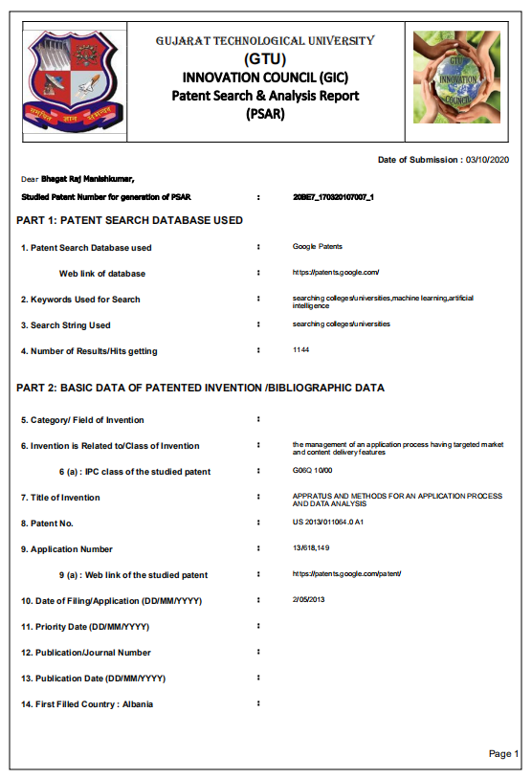

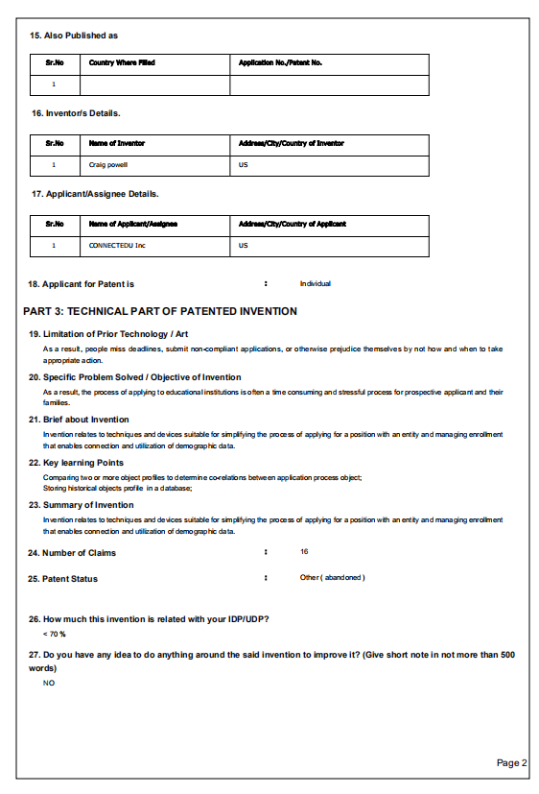

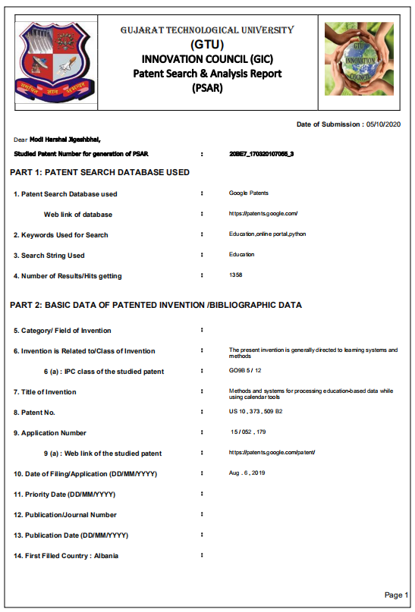

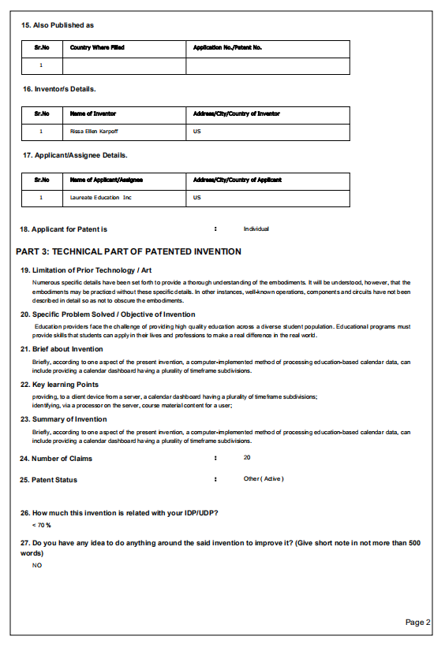

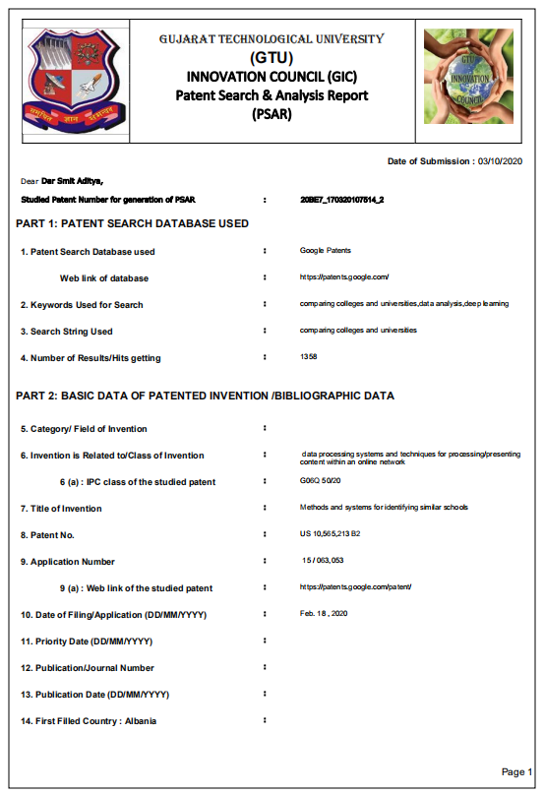

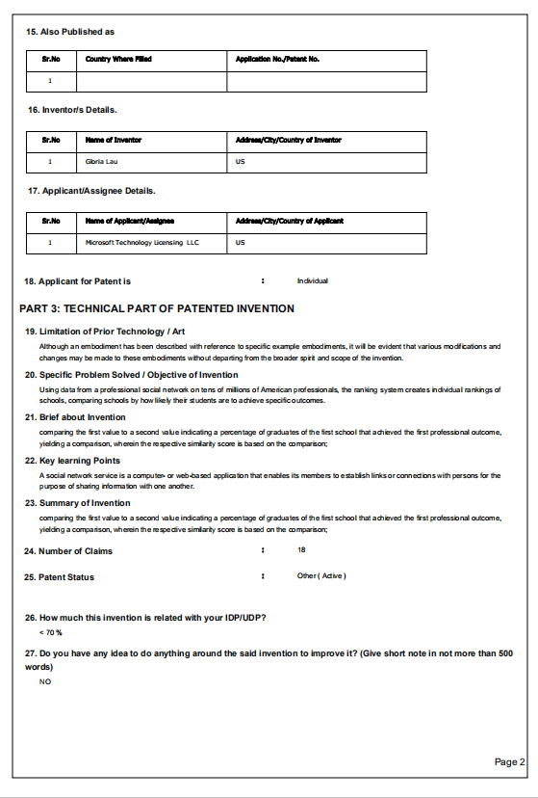

**10.3 Canvases**

1. **AEIOU Canvas**

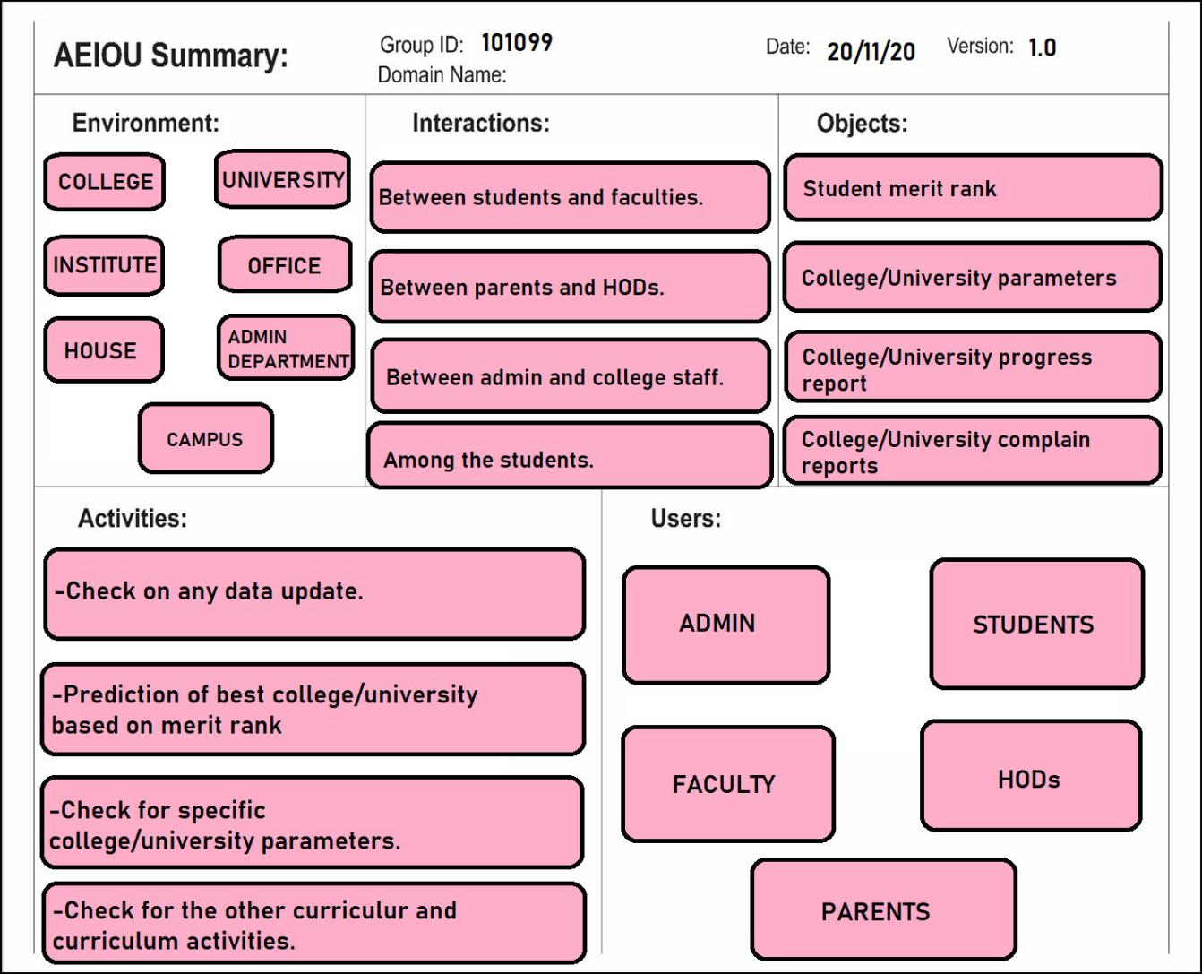

* **Environment:**

1. College
2. University
3. Institute
4. Office
5. House
6. Admin Department
7. Campus

* **Interactions:**

1. Between students and faculties.
2. Between parents and HODs.
3. Between admin and college staff.
4. Among the students.

* **Objects:**

1. Students merit rank
2. College/University Parameters
3. College/University Progress report
4. College/University Complain reports

* **Activities:**

1. Check on any data update.
2. Prediction of best College/University based on merit rank.
3. Check for specific College/University parameters.
4. Check for other curricular and curriculum activities.

* **Users:**

1. Admin
2. Students
3. Faculty
4. HODs
5. Parents
6. **Ideation Canvas**

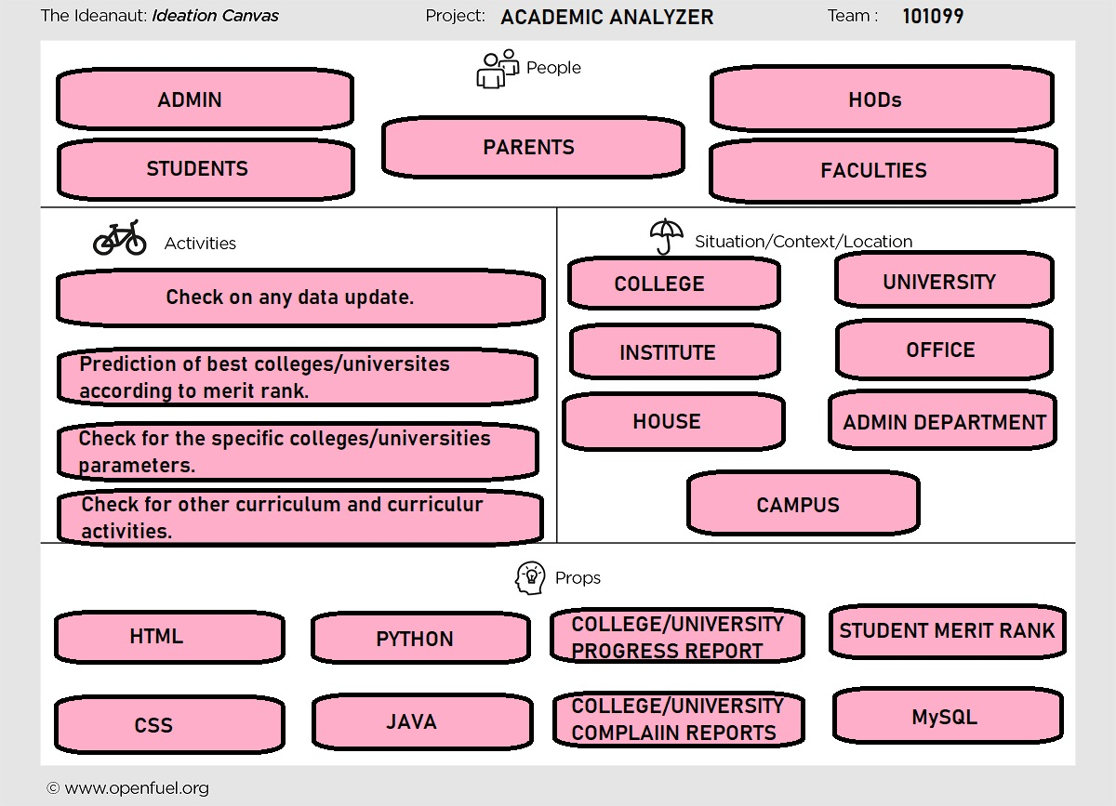

* **People:**

1. Admin
2. Students
3. Parents
4. HODs
5. Faculties

* **Activities:**

1. Check on any data update.
2. Prediction of best College/University based on merit rank.
3. Check for specific College/University parameters.
4. Check for other curricular and curriculum activities.

* **Situation/Context/Location:**

1. College
2. University
3. Institute
4. Office
5. House
6. Admin Department
7. Campus

* **Props:**

1. HTML
2. CSS
3. JAVA
4. PYTHON
5. MySQL
6. Student Merit Rank
7. Colleges/Universities Progress Report
8. Colleges/Universities Complain Report
9. **Product Development Canvas**

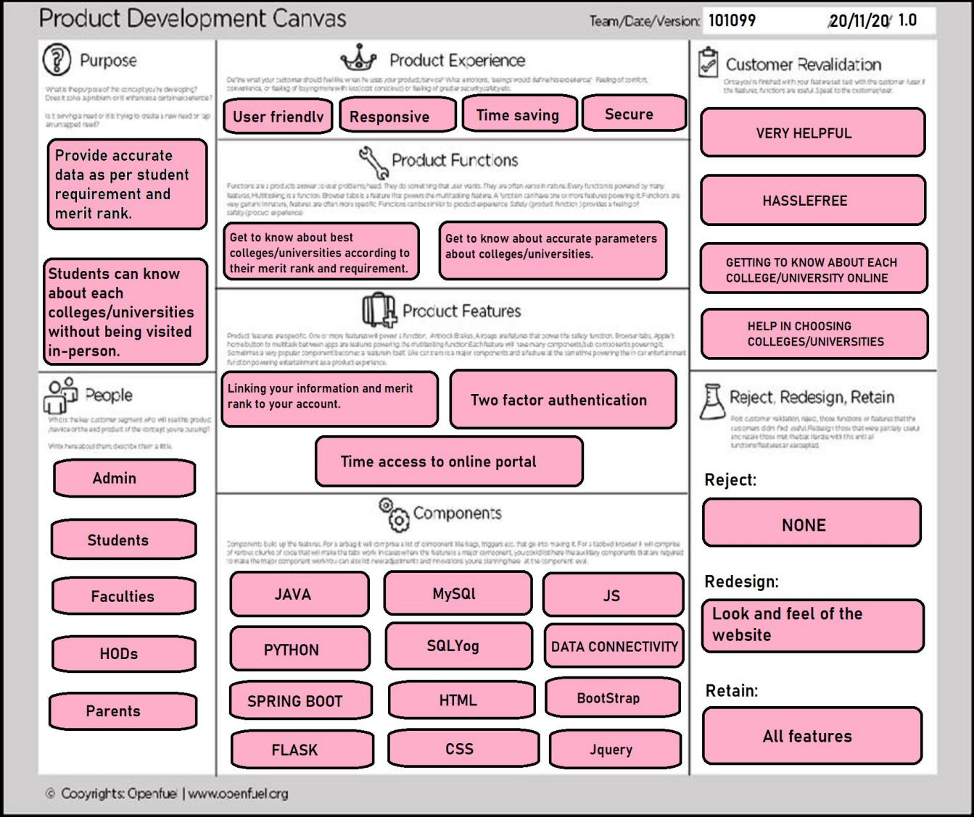

* **Purpose:**

1. Provide accurate data as per student requirement and merit rank.
2. Students can know about each universities/colleges without being visited in-person.

* **People:**

1. Admin
2. Students
3. Faculties
4. HODs
5. Parents

* **Product Experience:**

1. User Friendly
2. Responsive
3. Time Saving
4. Secure

* **Product Features:**

1. Linking your information and merit rank to your account.
2. Time access to online portal.
3. Two factor authentication.

* **Product Functions:**

1. Get to know about best colleges/universities according to their merit rank and their requirement.
2. Get to know about accurate parameters about colleges/universities.

* **Components:**

1. JAVA
2. PYHTON
3. HTML
4. MySQL
5. BOOTSTRAP
6. FLASK
7. SPRINGBOOT
8. SQLYog
9. CSS
10. JS
11. DATA CONNECTIVITY
12. Jquery

* **Customer Revalidation:**

1. Very Helpful
2. Hasslefree
3. Getting to know about each colleges/universities
4. Help in choosing colleges/universities

* **Reject:**

None

* **Redesign:**

1. Look and feel of the website

* **Retain:**

1. All Features
2. **Empathy Canvas**

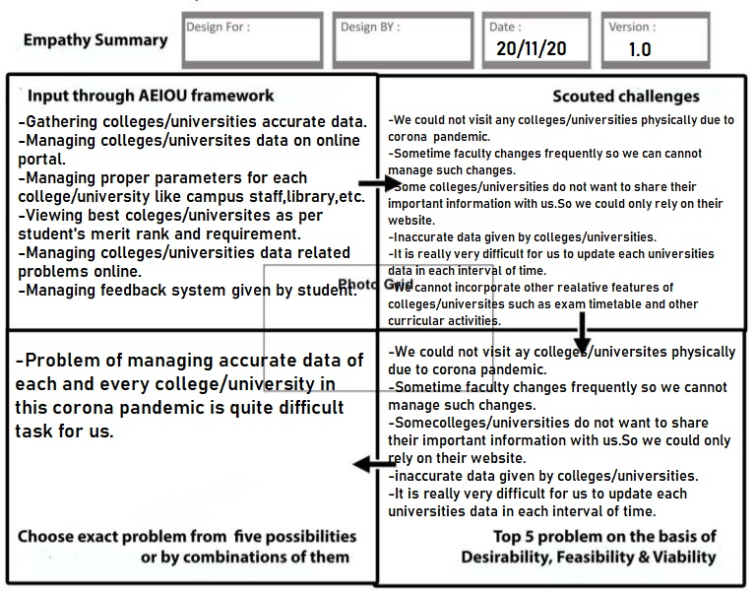

* **Input through AEIOU framework:**

1. Gathering colleges/universities accurate data.
2. Managing colleges/universities data on online portal.
3. Viewing best colleges/universities as per students merit rank and requirement.
4. Managing colleges/universities data related problems online.
5. Managing feedback system given by students.

* **Scouted Challenges:**

1. We could no visit any colleges/universities physically due to corona virus pandemic.
2. Sometimes faculty changes frequently so we cannot manage such changes.
3. Some colleges/universities do not want to share their important information with us.So we could not rely on their website.
4. Inaccurate data given by colleges/universities.
5. It is very difficult for us to update data of each colleges/universities in regular interval of time.
6. We cannot incorporate other relative features of colleges/universities like exam timetable.

* **Top 5 problems on basis of Desirability,Feasiability and Viability:**

1. We could no visit any colleges/universities physically due to corona virus pandemic.
2. Sometimes faculty changes frequently so we cannot manage such changes.
3. Some colleges/universities do not want to share their important information with us.So we could not rely on their website.
4. Inaccurate data given by colleges/universities.
5. It is very difficult for us to update data of each colleges/universities in regular interval of time.

* **Choose exact problem from 5 possibilities orby combinations of them:**

1. Problems of managing accurate data of each and every college/university in this corona pandemic is quite difficult task for us.

**10.4 Plagarism Certificate:**

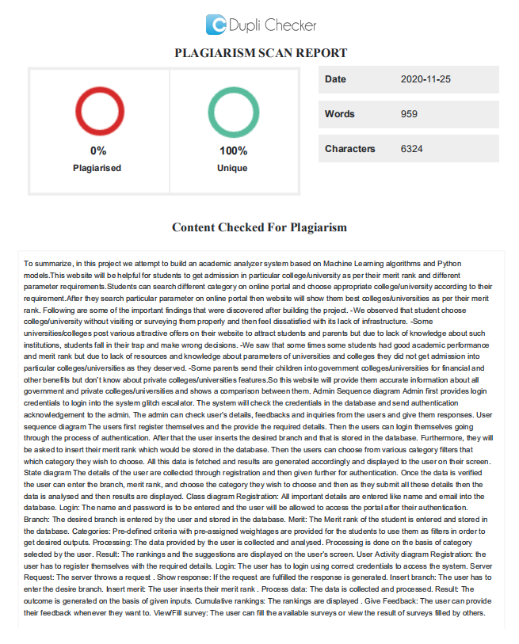

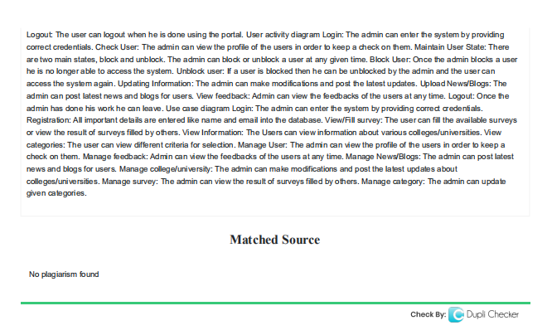

1.